Web Fundamentals & Intro to HTML
Class 1 notes. Where the course is headed, how the web actually works, and your first real HTML page.
Class: 1 · Project ahead: Portfolio website
Why this matters: This is where the building starts. By the end you will know what happens when you type a URL, and you will have written a real HTML page with structure, headings, links and images. Everything in the rest of the course sits on top of this.

What you should be able to do after this
- Describe the journey of a web request across client, DNS, server and database
- Explain how HTML, CSS and JavaScript split the work between them
- Set up VS Code and write a valid HTML boilerplate from scratch
- Use the core tags: headings, paragraphs, images, links, buttons and div
- Say why semantic tags beat a pile of divs

What's inside
1. The road ahead
2. How the web works
3. HTML, CSS & JavaScript: who does what
4. Your first HTML file
5. The core HTML tags
6. Structure: from div to semantic
7. Push your code to GitHub

1. The road ahead
In one line: Four modules, each one ending in a project you can actually show people.
Key points
- HTML/CSS, 7 classes, ending in a portfolio website.
- JavaScript + DOM, 22 classes, ending in a Kanban board and mini projects.
- React, 13 classes, ending in a movies app.
- MERN, 12 to 14 classes, ending in a BookMyShow style app.
- You will get the resources you need for each module as you reach it, not all at once.
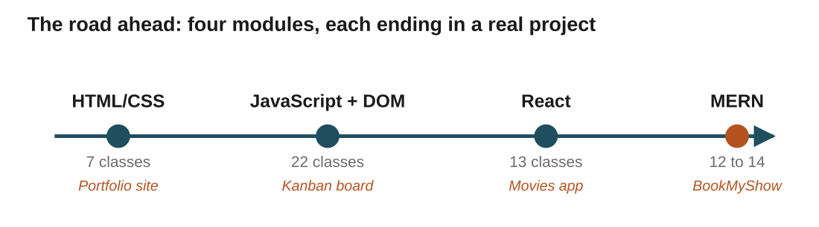
Figure 1: the whole journey. Each dot is a module, and each project is proof you can build the thing, not just watch a video about it.
In the real world: The portfolio you start this week is the same one you keep polishing as your CSS gets better. By class 7 it is something you can put a real link to.

2. How the web works
In one line: A URL locates a resource, and four players cooperate to fetch it and hand it back.
Think of it like: A dairy farm taking orders. The customer orders (client), an ops team routes each order (DNS), the farm assembles the product (server), and the warehouse holds the goods (database).
Key points
- URL (Uniform Resource Locator) locates one specific resource: a page, an image, a video.
- Client is you and your browser, the one asking for something.
- DNS is the phonebook of the internet. It turns scaler.com into the IP address of a machine.
- Server is a program, not a place. It receives your request and prepares a response by following set rules (protocols).
- Database is where the actual data lives, ready to be fetched.
- A server is not a database. It is the worker that fetches from the database and sends it back.
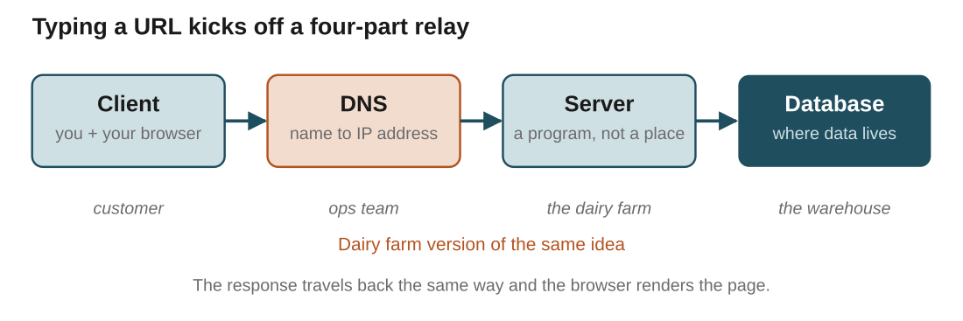
Figure 2: the relay from your keystroke to the data and back. Same shape as the dairy farm, just with less milk.
In the real world: You type scaler.com and hit enter. DNS looks up the IP the way a phonebook turns a name into a number, the server assembles the page, and the browser draws it. All of that happens before you have finished blinking.
Watch out: The common mix-up is thinking the server stores the data. It doesn't. The server assembles and serves; the database stores.

3. HTML, CSS & JavaScript: who does what
In one line: Structure, style and behaviour, split across three languages.
Think of it like: Building a shopping mall. First a blueprint, then the brick structure, then the paint, then the escalators and payment gates.
Key points
- Wireframe is the blueprint. Plan the layout first (Figma, Adobe XD), usually the UX team's job.
- HTML is the structure, the brick-and-mortar skeleton that holds the page up.
- CSS is the paint and polish, the colour and layout that make it pleasant to look at.
- JavaScript is the moving parts: escalators, lifts, payment gates. Interactivity when the user does something.
- Same page, three jobs. Keep them separate in your head and the code stays sane.
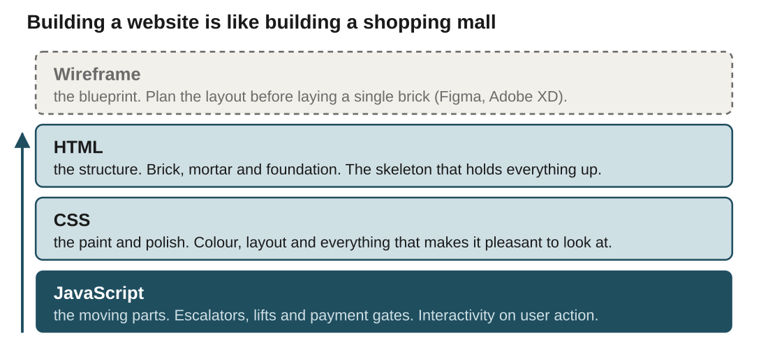
Figure 3: each layer sits on the one below it. Skip the structure and there is nothing to paint.
In the real world: Turn off CSS on any website with a browser extension and it still works, it just looks like it lost a fight. That naked page is the HTML doing its job with nothing on top.
Watch out: Interactivity like a success message on a click, or showing and hiding a section, is JavaScript's job, not HTML's. HTML only lays out what is there.

4. Your first HTML file
In one line: Install VS Code, create index.html, and understand every line of the boilerplate.
Key points
- VS Code is an IDE (integrated development environment): where you write and test code. It is free, lightweight, and from Microsoft.
- Download it from code.visualstudio.com, open a folder, and give it your batch name.
- Create index.html, type an exclamation mark, hit enter, and Emmet drops in the boilerplate.
- Install the Live Server extension so the page reloads as you save. Turn on auto-save while you are at it.
- HTML is case-insensitive for tags, so head, HEAD and HeAd all work. Stick to lowercase anyway, for your own sanity and everyone reading after you.
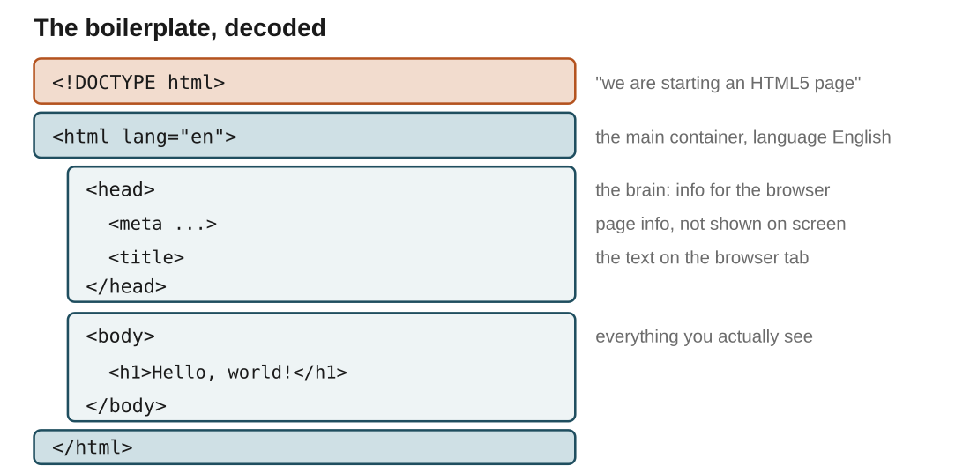
Figure 4: the boilerplate line by line. head is the brain (info for the browser), body is everything you actually see.
In the real world: Put <h1>Hello, world!</h1> inside the body, save, and Live Server shows it instantly. The title in the head is what names the browser tab, not anything on the page.
Watch out: Meta tags live in the head and never show on the page. They are notes to the browser and search engines, and we go deeper on them in a later class.

5. The core HTML tags
In one line: A handful of tags cover most of what you see on a page.
Key points
- Headings h1 to h6 carry rank, not just size. h1 is the main title, and it drops from there.
- Paragraph p holds descriptive text. Emmet's lorem shortcut fills it with placeholder text fast.
- Image img is self-closing and takes attributes: src (where the image is) and alt (text shown if it fails to load).
- Attributes are extra detail on a tag, like adjectives on a noun or features on a car.
- Anchor a makes a hyperlink with href, and target="_blank" opens it in a new tab.
- Button creates a clickable element that will later trigger actions.
- Comments in HTML are notes to yourself that the browser ignores.
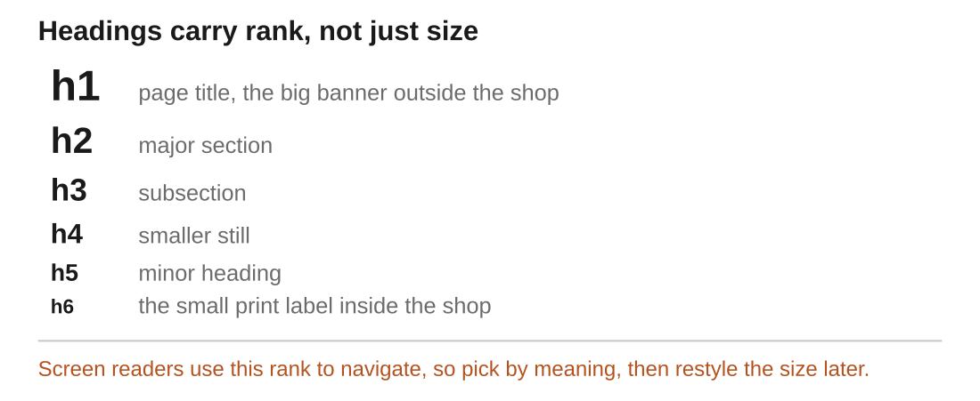
Figure 5: pick a heading by what it means in the outline, then let CSS handle how big it looks.
In the real world: In a mall, the brand's banner outside is huge, but the label inside the shop is small. Headings work the same way: h1 is the banner, h6 is the small label, and both are still headings.
Watch out: alt text is not optional polish. It is what a screen reader reads aloud and what shows when an image breaks, so write it as if the picture is missing.

6. Structure: from div to semantic
In one line: Group content with div, then upgrade to tags that actually name the parts.
Think of it like: A book with no chapters, index or headings is technically readable and practically miserable. Semantic tags are the chapters and index for your page.
Key points
- div is an invisible box that groups content, like rooms in a house: header, footer, content, buttons.
- Divs are great for grouping, but every div looks identical to a browser or a screen reader.
- Semantic tags (HTML5) replace generic divs with meaningful ones: header, nav, section, main, aside, footer.
- They make the layout readable to browsers, screen readers and search engines, not just to you.
- section groups a logical part of the page; header holds the top bar and nav. Reach for these before a plain div.
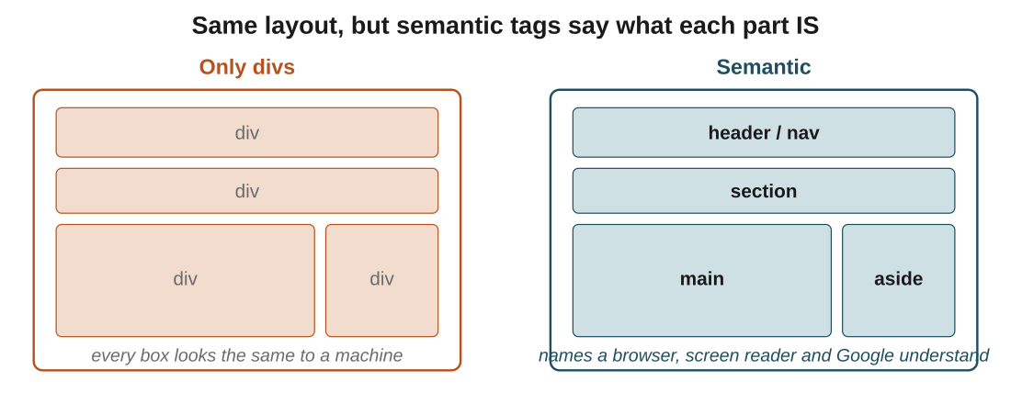
Figure 6: the two pages look the same in a browser. Only the right one tells a machine what each block is for.
In the real world: The portfolio you build uses header for the top nav and profile, then section blocks for About and Projects. A wall of unlabelled divs ("div soup") would render the same and help nobody.
Watch out: Semantic tags don't change how the page looks by themselves. Their payoff is meaning: accessibility and SEO, which quietly matter a lot.

7. Push your code to GitHub
In one line: Get an account now so you can grab the class code every session.
Key points
- GitHub is a big online library for code. Every project is a book others can read, copy and improve.
- It tracks every change, so you can always see who changed what and when.
- Sign up, then get the class repository link from your instructor.
- You don't need to learn git commands today. Just make sure you can access the shared code.
In the real world: After each section, the instructor pushes that section's code to the batch repo. Cloning or copying from there means you are never stuck re-typing what was on screen.

Quick recap
- The web is a relay: client to DNS to server to database, and the response comes back to the browser to render.
- A server is a program that assembles a response; the database is where the data actually lives.
- HTML is structure, CSS is style, JavaScript is behaviour. Same page, three separate jobs.
- Every HTML page is a boilerplate: head holds info for the browser, body holds what you see.
- Core tags: headings h1 to h6, p, img (with src and alt), a, button, and div for grouping.
- Semantic tags name the parts of a page, which helps accessibility and SEO where plain divs can't.
- Set up VS Code with Live Server, and a GitHub account to grab the class code.

Try it yourself
- Install VS Code and Live Server, create index.html, and get "Hello, world!" showing in the browser.
- Write a heading, a paragraph, an image with real alt text, and a link that opens in a new tab.
- Turn off CSS on a site you use with a browser extension, and note what still works and what falls apart.
- Rebuild one screen using semantic tags (header, nav, section, main) instead of divs, and start the portfolio header.

